Case 6-Afr-Mali-Dogon-Granary door

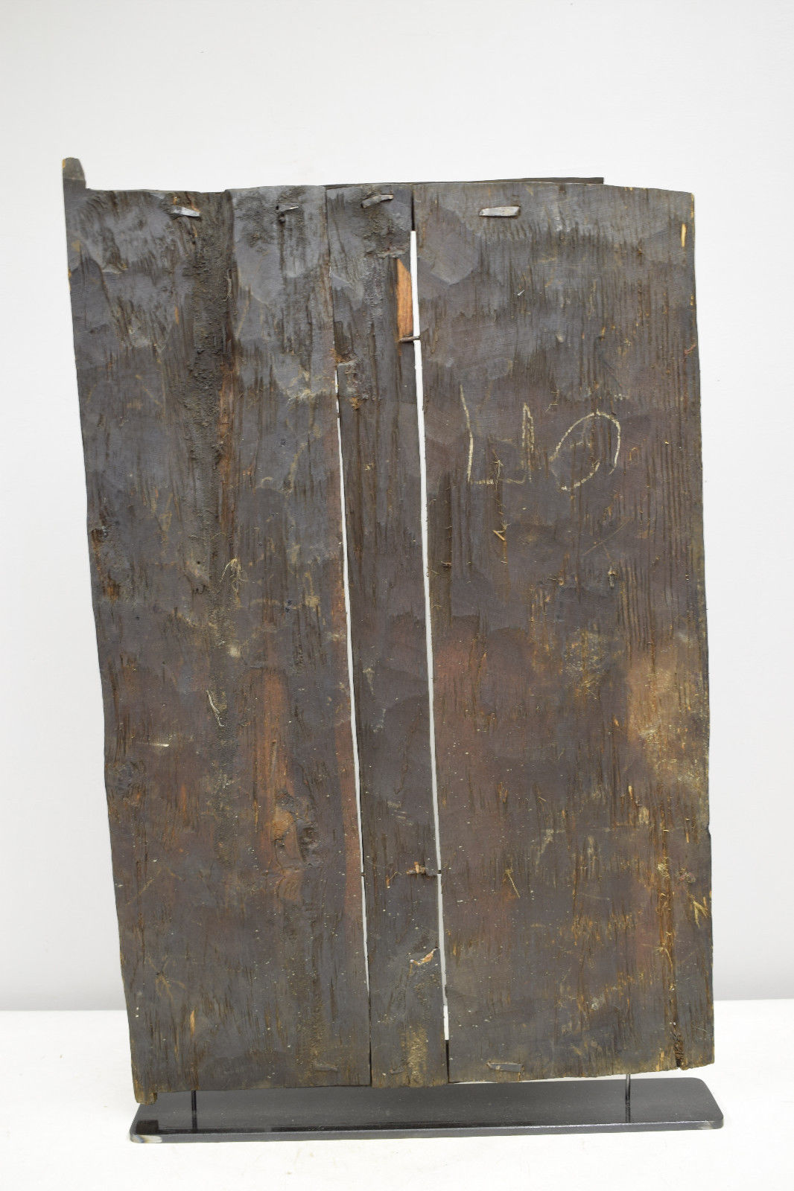

Dogon Granary Door from Mali. These doors protected the window-like opening into each family's grain storage building, and used a simple sliding door lock. Primordial beings, ancestors, Kanaga masks, sun lizards and scenes of life symbolically served to protect the entrance by making it sacrosanct.

This is a beautifully carved Granary Door from the Dogon People of Mali. These doors protected the window-like opening into each family's grain storage building, and used a simple sliding door lock. Primordial beings, ancestors, Kanaga masks, sun lizards and scenes of life symbolically served to protect the entrance by making it sacrosanct. The low reliefs are carved on several panels, held together by iron staples. The Dogon are justifiably famous for their doors. Whether complex or plain, figurative or abstract, solid or weathered by the elements and use. Dogon doors are basically carved doorways and are a significant part of ancient West African life. The doors were initially designed to show social standing of the household. For the Agrarian societies of West Africa, granary doors are an especially important representation of wealth and prosperity of the farmer. Dogon people of Mali have created an art form in their granary doors.

Note the stand at bottom